MERN STACK REACT WEEK 4:

1.Code:

function Greeting(){

return <h1>Hello World!</h1>;

}

export default Greeting;

Output:

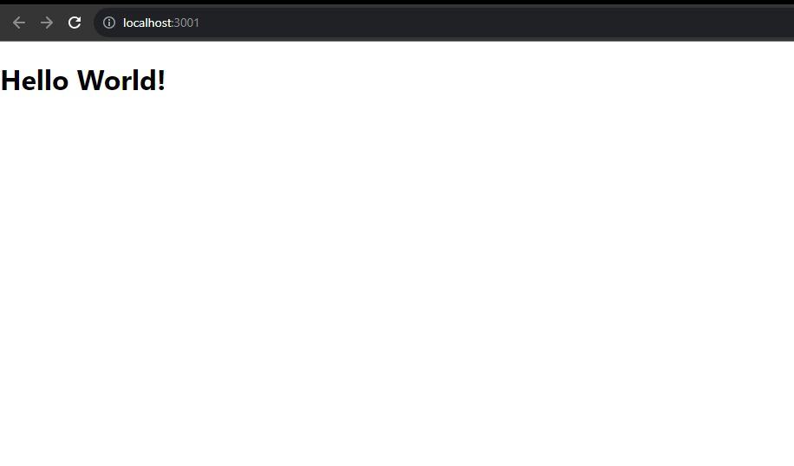

2. Code:

function Greeting(){

return <h1>Hello, React!</h1>;

}

export default Greeting;

Output:

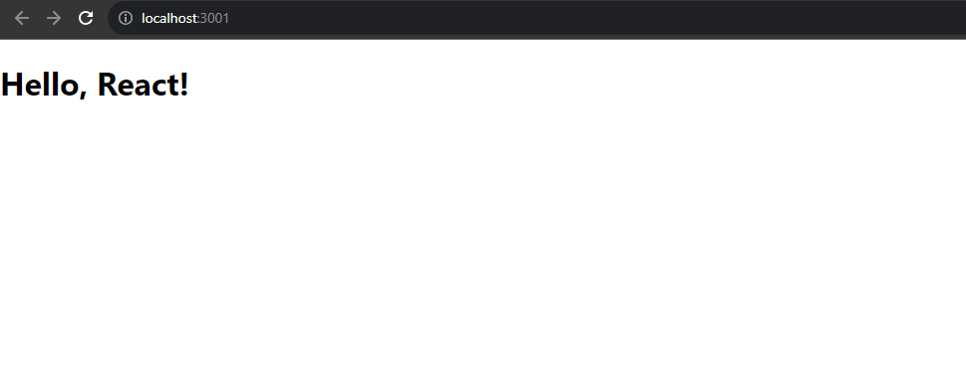

3.Code:

import chan from './chan.jpg'

 function Gallery(){

       return <img src={chan} height="200px" width="300px" alt="hi"></img>

}

export default Gallery;

Output:

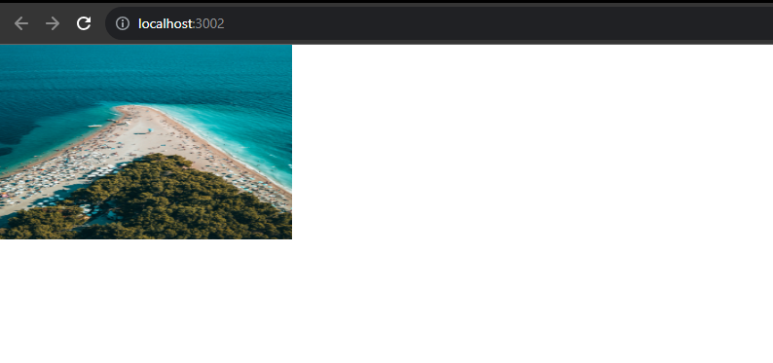

4.Code:

import Greeting from './Greeting';

import chan from './chan.jpg'

 function Gallery(){

       return <>

        <img src={chan} height="200px" width="300px" alt="hi"></img>

       <Greeting/>

       </>

}

export default Gallery;

function Greeting(){

return <h1>Hello, React!</h1>;

}

export default Greeting;

Output:

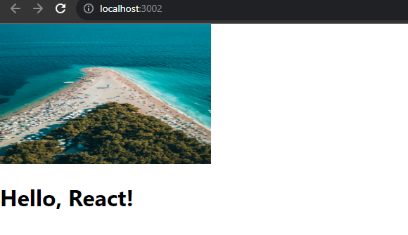

5.Code:

Index.js

import Profile from './Profile'

const root = ReactDOM.createRoot(document.getElementById('root'));

root.render(

  <React.StrictMode>

    <Profile name="John" age="18"  />

  </React.StrictMode>

);

Profile.js

import Profile from './Profile'

const root = ReactDOM.createRoot(document.getElementById('root'));

root.render(

  <React.StrictMode>

    <Profile name="John" age="18"  />

  </React.StrictMode>

);

Output:

